Encyclopedic Dictionary

What is Encyclopedic Dictionary
# Source: AI Source: Provided by: [Data Path: Persons Table -> ID Column: 1, Name_En Column: Motasem Essam] -> From: [Chatgpt (GPT-4-turbo)] on [7/29/2025]
An Encyclopedic Dictionary combines the features of a dictionary and an encyclopedia. While it provides definitions of words, it also includes expanded information about concepts, events, people, and places, often with historical, scientific, or cultural context. These entries go beyond meaning to offer informative explanations.

🔹 Key Features of an Encyclopedic Dictionary
# Source: AI Source: Provided by: [Data Path: Persons Table -> ID Column: 1, Name_En Column: Motasem Essam] -> From: [Chatgpt (GPT-4-turbo)] on [7/29/2025]
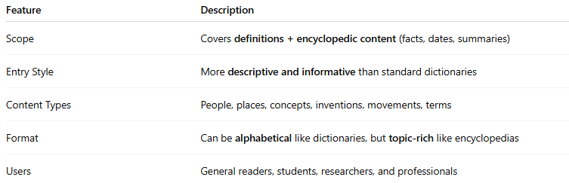
Feature | Description
Scope | Covers definitions + encyclopedic content (facts, dates, summaries)
Entry Style | More descriptive and informative than standard dictionaries
Content Types | People, places, concepts, inventions, movements, terms
Format | Can be alphabetical like dictionaries, but topic-rich like encyclopedias
Users | General readers, students, researchers, and professionals

🔹 Examples of Encyclopedic Dictionaries
# Source: AI Source: Provided by: [Data Path: Persons Table -> ID Column: 1, Name_En Column: Motasem Essam] -> From: [Chatgpt (GPT-4-turbo)] on [7/29/2025]
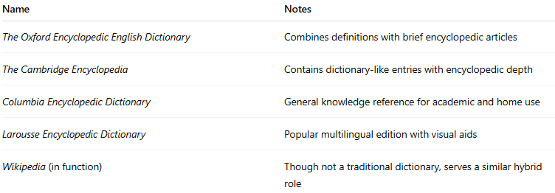
Name | Notes
The Oxford Encyclopedic English Dictionary | Combines definitions with brief encyclopedic articles
The Cambridge Encyclopedia | Contains dictionary-like entries with encyclopedic depth
Columbia Encyclopedic Dictionary | General knowledge reference for academic and home use
Larousse Encyclopedic Dictionary | Popular multilingual edition with visual aids
Wikipedia (in function) | Though not a traditional dictionary, serves a similar hybrid role

🔹 Advantages
# Source: AI Source: Provided by: [Data Path: Persons Table -> ID Column: 1, Name_En Column: Motasem Essam] -> From: [Chatgpt (GPT-4-turbo)] on [7/29/2025]
- Provides broader context than a standard dictionary
- Useful for quick fact-checking or background reading
- Supports academic writing, essay preparation, and general learning
- Combines language learning with general knowledge acquisition

🔹 Use Cases
# Source: AI Source: Provided by: [Data Path: Persons Table -> ID Column: 1, Name_En Column: Motasem Essam] -> From: [Chatgpt (GPT-4-turbo)] on [7/29/2025]
- General education and reference
- Essay writing and research
- Cross-disciplinary learning
- Fact-checking and conceptual clarity

